|  |  |
| --- | --- |
|  | National Training Agency |
|  | Version 2.0 |



|  |
| --- |
| **[**TVET Control Centre User Manual – Candidate Management**]** |
| To assist candidates in navigating the functions of the TVETCC. |

### Revision History

|  |  |  |  |
| --- | --- | --- | --- |
| Version | Date | Revision Description | Last Edited by |
| 1.0 | 02 Jan 2013 | Initial release | Nari Mohan |
| 2.0 | Apr 2022 | Content and layout updated | MGD |

Table of Contents

1.1.1. Revision History ii

1. Introduction 1

1.1. Purpose 1

1.2. Intended Audience 1

1.3. Acronyms and Abbreviations 2

2. Application Overview for Candidates 3

2.1. Organization of Manual 3

2.2. Reference to other manuals 3

3. Getting Started 4

3.1. Accessing the TVET Control Centre 4

3.2. User Login Credentials 4

3.3. User Access Level 5

3.4. Changing Password 6

3.4.1. Password Recovery 6

3.5. Logging out 6

4. Using The My Candidate Portal page 7

4.1. My Panel 8

4.1.1. My Candidate Profile 8

4.2. Certification Panel 12

4.2.1. Record of Achievement 12

4.3. PLAR Panel 13

4.3.1. My PLAR Qualification Plans (x) 13

4.4. Assessment Panel 17

4.4.1. My Self Assessments 17

4.4.2. Upcoming Assessments 18

4.4.3. Assessment Results 18

4.4.4. My RTP Qualification Plans 18

5. Step-by-Step Guide for Candidate 19

6. Error Handling 20

6.1. Common Errors 20

6.2. Help Facilities 20

7. Appendix A - Glossary 21

# Introduction

The national TVET Control Centre (TVETCC) is a secure online database solution designed to collect and store information, within the TVET System, on:

* TVET Training Providers that are Enterprise, Community, Institution and School based
* Training Programs
* Trainers/Assessors
* Trainees/Graduates.

The TVETCC facilitates the interaction of stakeholders involved in the certification process towards the Trinidad and Tobago National Vocational Qualifications (TTNVQs) or Caribbean Vocational Qualifications (CVQs).

Stakeholders include the candidates, training providers’ administration, assessors, verifiers and the staff of the National Training Agency (NTA).

## Purpose

The purpose of this manual is to provide all the necessary information to navigate the TVETCC as a candidate. The manual assumes that the user is a candidate pursuing a TTNVQ or CVQ.

## Intended Audience

This manual is intended for persons performing the role of candidates such the trainees, students, learners, PLAR candidates, assessor-candidates etc. who are pursuing a national or Caribbean Vocational Qualification.

## Acronyms and Abbreviations

|  |  |
| --- | --- |
| **CVQ** | Caribbean Vocational Qualification |
| **NTA** | National Training Agency |
| **PLAR** | Prior Learning Assessment and Recognition |
| **RTP** | Registered Training Provider |
| **TTNVQ** | Trinidad and Tobago National Vocational Qualification |
| **TVET** | Technical Vocational Education & Training |
| **TVETCC** | TVET Control Centre |

# Application Overview for Candidates

Candidates are persons registered in the system with the intention of pursuing a TTNVQ or CVQ with the aim of being assessed and certified. The TVETCC allows a user to register for a candidate account. A candidate can also be registered by a training provider or an assessor. This user account allows a candidate to:

* Manage their profile
* Conduct self-assessments against available qualifications
* Apply for Prior Learning Assessment and Recognition (PLAR)
* View current programmes being pursued
* View awarded units and qualifications
* View Record of Achievement (RoA)

## Organization of Manual

## Reference to other manuals

Please see the *TVET Control Centre User Manual – Assessor Management* for persons in the role of the assessor, internal verifier or external verifier.

Please see the *TVET Control Centre User Manual – Training Provider Management* for persons in the role of the Training Provider Administration. .

# Getting Started

## Accessing the TVET Control Centre

The TVET Control Centre is accessed via a web browser and is available on the World Wide Web. The url is [www.ntatvetcentre.org](http://www.ntatvetcentre.org) .

The website is compatible with all major browsers: Google Chrome, Microsoft Edge, Mozilla Firefox, Safari, Netscape, Opera and Internet Explorer 6 and above. This is by no means an exhaustive list; there are smart phones and other hand-held devices which can also be used to gain access to the website technologies.

The General Public can browse the site, create searches and gather general information. Some features of the site are restricted to privileged user accounts.

## User Login Credentials

User credentials refer to the paired username and password which is required to allow a user access to the website. The paired key is used to uniquely identify each user to the system. Users should make every effort to secure these keys to ensure that only authorized persons gain access and to prevent unwanted exploitation of the user’s account.

Figure 1

To log in, the user will be required to click the Login navigation link at the top of the screen (see Figure 1). The user will then fill out the fields provided by entering their User Name and Password. Next, click the **Login** button below the field or simply press the Enter key on the keyboard (see Figure 2).

**

Figure 2 User Login

The User Name for a candidate account has an alphanumeric format. Usually, the first 2 letters of the first name plus the first 2 letters of the last name followed by a unique number.

On first login, you may be required to change your password to ensure greater security. Please enter your old password [received in the email] and enter the new password [both in the new password and confirm new password fields].

## User Access Level

The system is designed to facilitate users with varying user functions and roles. The same login screen is applicable to all users to enter but based on their login credentials, access to specific system features which will granted or denied.

## Changing Password

n the My Candidate Portal. The user will provide their user name, the current password, create a new password and then re-enter it for confirmation. Click the **Submit** button to record the password changes (see Figure 3).

Figure 3 Change Password

### Password Recovery

If the password is forgotten, click the **Forgot my Password?** link. The user provides the correct user name and submit. A new password will be generated for the user and sent to the email address saved for the user.

## Logging out

It is imperative for users to log out after completing their intended task. This is even more necessary for systems which have multiple users.



Figure 4 Log out

To log off the TVETCC, click the **Log Out** button (as highlighted on the image above).

# Using The My Candidate Portal page

After completing a successful login (see Getting Started on page 4), you will be taken to the portal page (see Figure 5).

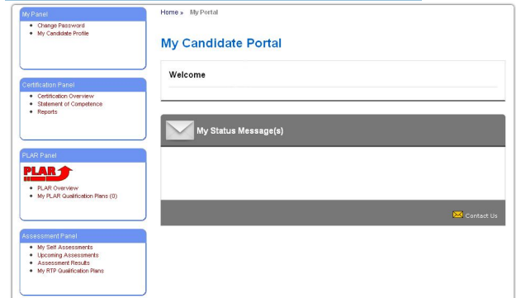

Figure 5 My Candidate Portal

At any time, users can click the “My Portal” link on the top of any screen to return to the My Candidate Portal.

As seen in Figure 5, the portal gives you quick access to the following functions

|  |  |
| --- | --- |
| **My Panel**   * Changing password * Viewing / Updating Profile Information   **Certification Panel**   * Viewing Record of Achievement | **PLAR Panel**   * Viewing PLAR qualifications plans   **Assessment Panel**   * Viewing self-assessments * Viewing upcoming assessments * Viewing assessment results * Viewing RTP qualification plans |

## My Panel

### My Candidate Profile

The Candidate Profile displays information collected from you, the candidate. The information is displayed on tabbed pages. There are separate tabs for standard profile information such as biographical information; educational history; and work and life experience.

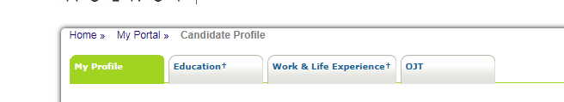

Figure 6 Candidate Profile Tabs

**My Profile Tab**

This tab displays your biographical information such as your name, unique identification numbers and contact information.

After your account has been created, some information cannot be edited e.g., the name and identification numbers. If there is an error in these fields, please notify the training provider so the information can be correctly updated.

**Education Tab**

This tab displays your certificates, if provided. You are able to enter all your educational and professional qualifications starting with the most recent.

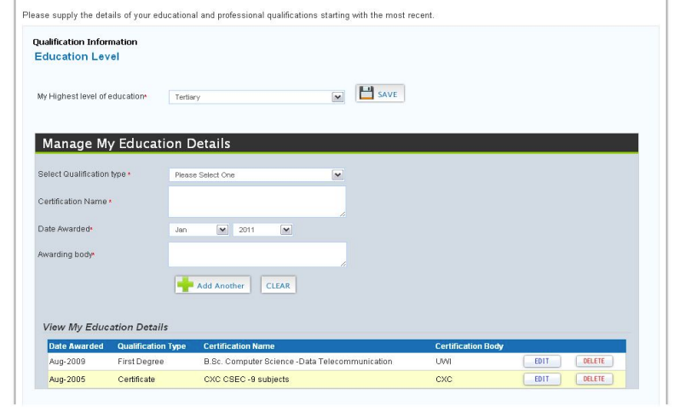

Figure 7 Candidate's Education Tab

You can select the highest level of education achieved and click **SAVE** button.

To enter the certificates, you have achieved, select the qualification type from the dropdown list, enter the certification name, grade, date awarded, sector and the awarding body and click **Add Another** to add the certificate.

The newly listed certificate appears at the bottom. You can edit the information by clicking the **EDIT** button or delete the information by clicking the **DELETE** button.

The Verified status refers to whether a training provider or assessor has seen physical proof of the certificate(s).

**Work and Life Experience tab**

This tab displays the information relating to your work history, if provided. You are able to supply the details of your last three jobs or employers, starting with the most recent employment as well as life experiences relating to the pursued qualification.

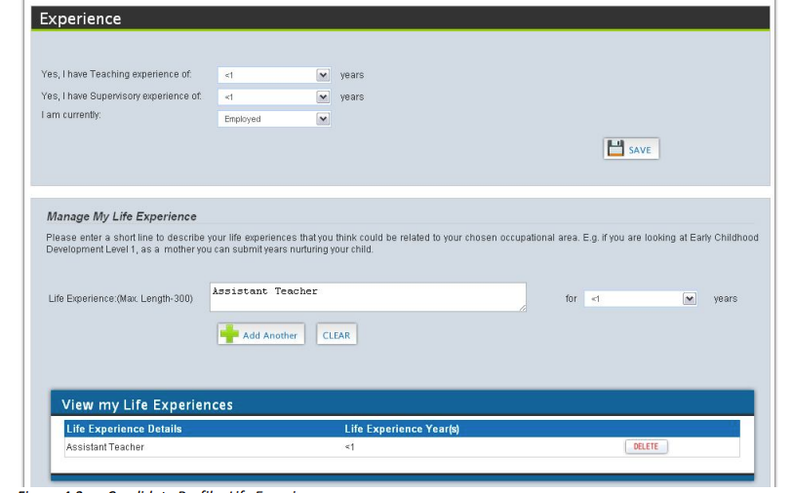

Figure 8 Life Experience Section

You can select the information that is applicable and then click the **SAVE** button.

The Manage Life Experience allows you to give a brief description of any of your experiences that you think could be related to your chosen occupational area.

The newly listed life experience appears at the bottom. You can delete the information by clicking the **DELETE** button.

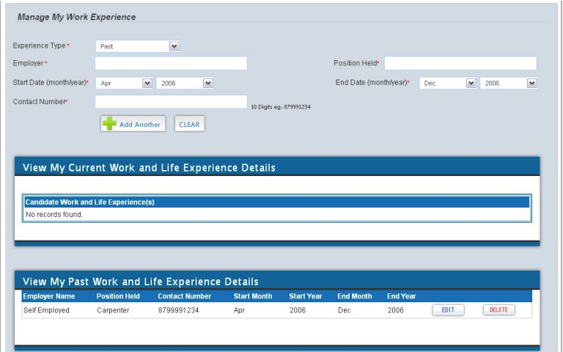

Figure 9 Work Experience Section

The work experience section is very much similar. You can enter all your work experience that you believe is relevant or related to your chosen occupational area. Simply complete the fields and then click **Add Another** button

The newly listed work experience appears at the bottom. You can edit the information by clicking the **EDIT** button or delete the information by clicking the **DELETE** button.

## Certification Panel

### Record of Achievement

The Record of Achievement (RoA) is a single document that lists all of the completed TTNVQs and CVQs and units that you currently awarded. To access click the link **Record of Achievement** from My Candidate Portal (Figure 5). This will redirect the you to the My Record of Achievement page(see Figure 10**Error! Reference source not found.**).

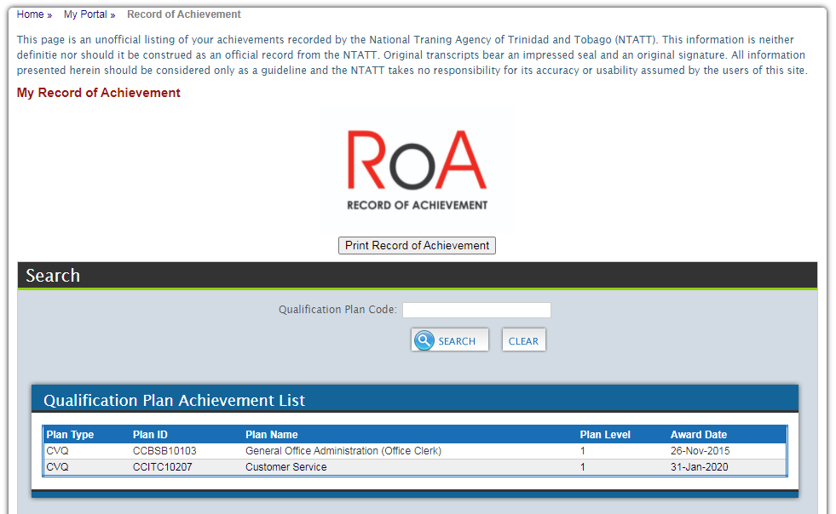

Figure 10 Record of Achievement

**Printing the RoA (Unofficial copy)**

To download an official copy of the RoA, click the **Print Record of Achievement** button. If it is your first time accessing the RoA, you would be asked to complete a short labour Market questionnaire. An unofficial copy of the RoA would then download onto your device.

For more information on the RoA, log on to the NTA’s website at www.ntatt.org.

## PLAR Panel

PLAR (Prior Learning Assessment and Recognition) is a process that identifies and assesses an individual’s knowledge, skills, and attitudes developed through work, training and/or life experiences to determine if you have met the requirements for certification.

For more information on PLAR, log on to the NTA’s website at www.ntatt.org

### My PLAR Qualification Plans (x)

X denotes the number of plans currently being pursed via PLAR. This link takes you to the **PLAR Qualification Plan Listing** screen where you can view the qualifications currently being pursued via PLAR as well as search other Qualifications and apply to pursue via PLAR.

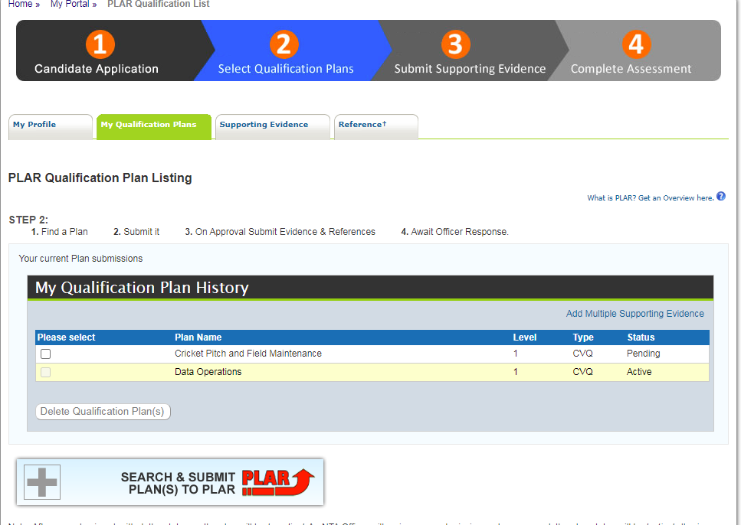

Figure 11 PLAR Qualification Plan Listing

**My Qualification Plan History**

This area displays the qualifications currently being pursued via PLAR

Click the link **Add Multiple Supporting Evidence** to add more evidence to your ePortfolio for the qualifications currently being pursued via PLAR. (see Figure 11)

**Requesting to pursue a Qualification via PLAR**

You can request to pursue a Qualification via PLAR by clicking the button **SEARCH & SUBMIT PLAN(S) TO PLAR** This would open a new area to search for a relevant qualification plan. You can use any of the filter to narrow down the search results. (see Figure 12)

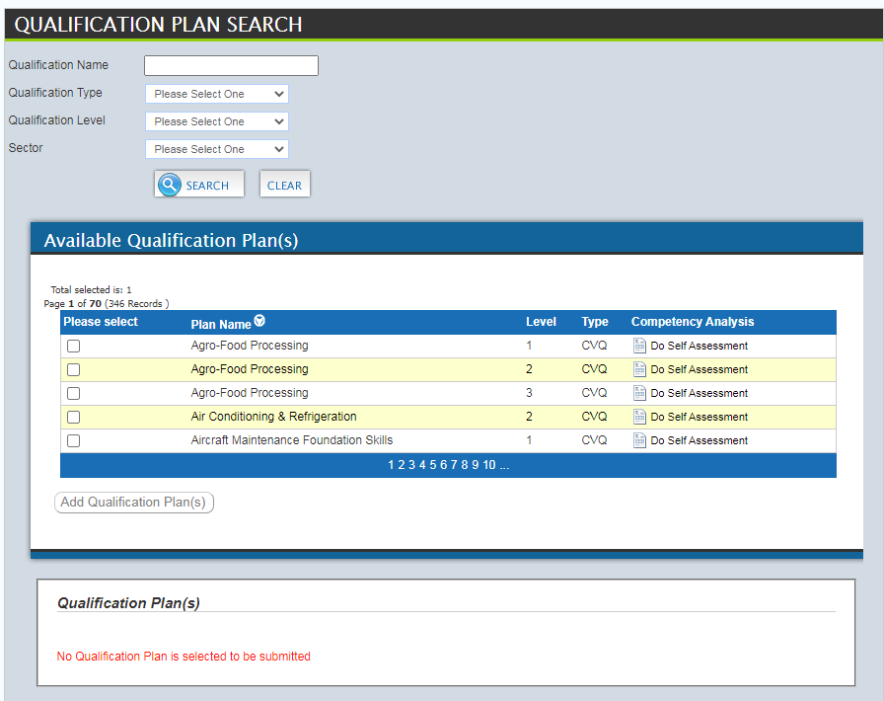

Figure 12 Qualification Plan Search

Once the desired qualification is located, select the matching check box to the life and then click the **Add Qualification Plan(s)** button. You must complete a self-assessment against the selected qualification plan before submitting your PLAR request (see section below on completing self-assessments). Once the self-assessment is completed, in the “Qualification Plan(s)” area below, select the “**I have completed the self assessment for the plan(s) above”** checkbox and then click the **Submit my Request** button

**Completing Self Assessment (or Competency Analysis)**

A self-assessment must be completed against the selected qualification plan before submitting your PLAR request. This helps to determine if you have the skills, knowledge and attitudes to pursue the qualification. In addition, it allows an assessor to gain an understanding of the level of development that you require.

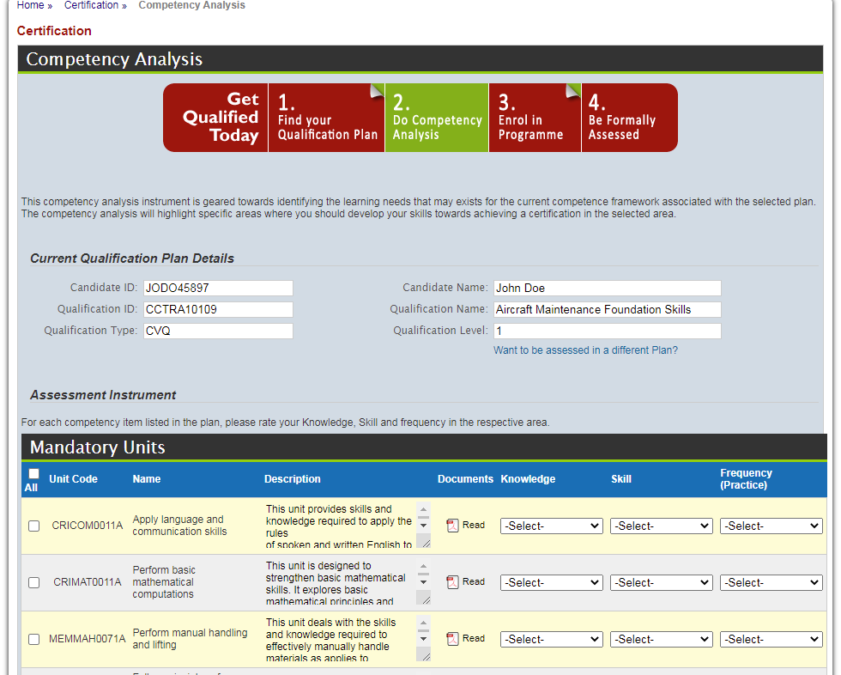

All the units for the qualification are listed, grouped by mandatory and elective. For each unit, you can read a brief description of the unit. You can click the **Read** link to download a copy of the unit in a Portable Document Format (pdf).

To complete the competency analysis (self-assessment), select one item from each of the three dropdown lists (Knowledge, Skills and Frequency) found on the right for each unit that you think are matched to your skill set.

After completing the selection, click the **See Result** button at the bottom of the page to save the entries and view the outcome of the self-assessment.

The Self - Assessment Competency Analysis Results specifies, based on your self-rating, those units which you are competent (Recommended for PLAR) and those which you would require training (Recommended for Training).

You can print the results by clicking the **Print Self Assessment Report** button. To access this report and any other previously done, click the **My Self Assessments** in the Assessment Panel section on the My Portal screen.

For more information on training, you would have to contact a relevant training provider.

## Assessment Panel

### My Self Assessments

To access all self-assessment results that were other previously done, click the **My Self Assessments** link in the Assessment Panel section on the My Portal screen. This will lead to another screen listing all past results. (see Figure 13)

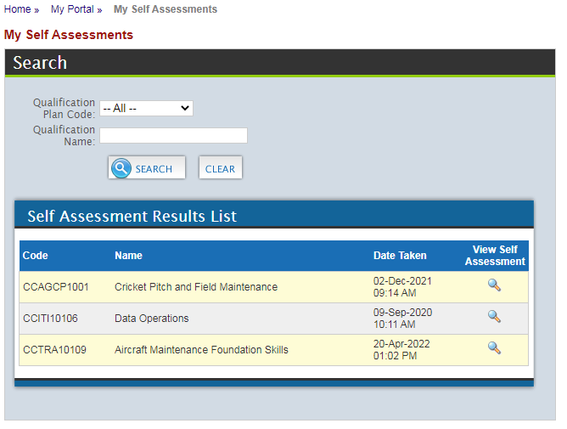

Figure 13 My Self-Assessments Results List

For each self-assessment result, you can click the  icon to view the result in detail and print the report.

### Upcoming Assessments

To access upcoming assessments submitted by the assessor, click the **Upcoming Assessments** link in the Assessment Panel section on the My Portal screen.

### Assessment Results

To access assessments results, click the **Assessments Results** link in the Assessment Panel section on the My Portal screen.

### My RTP Qualification Plans

To access assessments results, click the **My RTP Qualification Plans** link in the Assessment Panel section on the My Portal screen.

This section details the qualifications (TTNVQ or CVQ) pursued through a training provider

# Step-by-Step Guide for Candidate

The following functions can assist candidates in maximising use of the TVETCC towards the achievement of their TTNVQ/CVQ:

# Error Handling

## Common Errors

|  |  |  |
| --- | --- | --- |
| **Error** | **Possible Cause** | **Solution** |
| Unable to login | Password is either incorrect or expired. | If forgotten, try Forgot my Password? Link (see page 6)  else send email requesting password reset |
| Unable to update profile information | Editing of some fields such as name and birth certificate PIN are restricted. | Contact your assessor or training provider to update your information.  In the case where you do not have a current assessor/ training provider, send an email to the NTA requesting assistance in updating the information |

## Help Facilities

Our technical support team is ready to answer questions that may arise or provide technical assistance in dealing with any issue(s) that may arise. Feel free to contact any of the following members of our support team

* Michelle Ghatt Deane, TVETCC, Senior Coordinator (michelle-ghatt@ntatt.org)
* Nari Mohan, Systems Analysts
* Rose Uche-Nawachi, Database Administrator

Email : [tvetcc-support@ntatt.org](mailto:tvetcc-support@ntatt.org)

# Appendix A - Glossary

| Term | Definition |
| --- | --- |
| Assessor | A certified person authorized by an organisation to judge the performance of candidates against the occupational standards. |
| Candidates | An inclusive term referring to anyone learning, including students, apprentices, learners, interns; trainees, and people learning non-formally and informally as well as people enrolled for particular qualifications or part qualifications. |
| Centre Approval Process | The process that a centre must undergo to be granted permission by the Awarding Body to register and assess candidates for TTNVQs or CVQs |
| Certification | This is the process by which an approved centre requests, and the Awarding Body provides, a certificate for each candidate on completion of:  ♦ the entire set of units required for the award of the CVQ  ♦ one or more units of an CVQ (for those candidates not enrolled for a full CVQ |
| CVQ | The Caribbean Vocational Qualification (CVQ) is an award that represents achievement of a set of competencies which define core work practices of an Occupational area, consistent with the levels articulated within the regional qualifications’ framework. To earn an award, candidates must demonstrate competence in reaching CARICOM-approved occupational standards developed by practitioners and employers (i.e., the industry experts). These standards are organized in units. Candidates may earn unit awards towards achieving a complete CVQ. |
| Cycle | The time period stipulated for the delivery of training. |
| External Verifier | An External Verifier is an individual contracted by the Awarding Body to carry out a Quality Assurance Audit of the CVQ provision in an approved Centre to ensure that centres approved to offer CVQs are consistently judging candidates equally, fairly and in accordance with the regional occupational standards. |
| Internal Verifier | A person nominated by an approved centre who is responsible for internal quality assurance, mainly through assuring the quality and consistency of assessments by Assessor(s). |
| Satellite centre | Additional training centres (or sites) operating in a different location from the main training provider |
| Training Provider | An institute, enterprise or community-based organisation which provides training and/or facilitates the training process for the acquisition of competences in keeping with occupational and national standards, accredited facilities and vocational qualifications, and appropriate resources |
| TVET | Technical and vocational education and training’ (TVET) is understood as comprising education, training and skills development relating to a wide range of occupational fields, production, services and livelihoods.  TVET, as part of lifelong learning, can take place at secondary, post-secondary and tertiary levels and includes work-based learning and continuing training and professional development which may lead to qualifications. TVET also includes a wide range of skills development opportunities attuned to national and local contexts. Learning to learn, the development of literacy and numeracy skills, transversal skills and citizenship skills are integral components of TVET.  Source: UNESCO (GC) 2015, UN |
| Unit | Units are a set of learning outcomes (knowledge, skills, and attitude) which constitute a coherent part of a qualification. A unit can be the smallest part of a qualification that can be assessed, transferred, validated and, certified. A unit can be specific to a single qualification or common to several qualifications. |